**Curriculum Vitae**

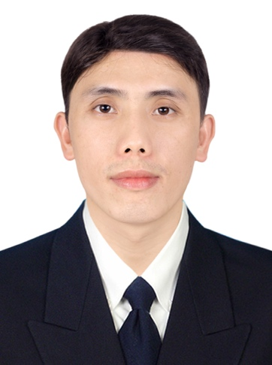

**I specialize in programming and I am particularly proficient in develop services for customers of all sizes, I am always eager to explore new technologies that can enhance the development process.**

**EDUCATION**

October 2016 to August 2020

National University of Laos, faculty of natural science, department of computer science, bachelor digree, computer science.

**PERSONAL**

FULL NAME:

Mr. Xuemoua YONGCHUE

**WORK EXPERIENCE**

17th Augaust 2024 to Present

Software engineer at Zion Group Sole Co., Ltd responsibility develop software, support MAXHUB software and Hard ware and leader of team

DATE OF BIRTH:

08 December 1995

1st Apirl 2021 to 16th Augaust 2024

Junior software engineer at Loca company limited responsibility develop software, support team and leader of team

PLACE OF BIRTH:

Xiengkhouang Province

NATIONALITY: Lao

16 November 2020 to 18 February 2021

Junoir software engineer at Lailaolab ICT Solutions ., Ltd develop mobile application for Ministry of Planning and investment

**CONTACT**

PHONE:

+8562077412886, +8562055932540

12 Octorber 2020 to 12 November 2020

IT Support and network at Techno Genius Company solve issue of computer and design network system for the company.

EMAIL:

xuemoua995@gmail.com



ADDRESS:

Dongdok Village, Xaythany District,Vientiane Capital

2 July 2020 to 3 August 2020

Junior software engineer at 108 JOBS company responsibility develop the company website.

Octorber 2019 to December 2019

Teaching English for computer to student second year at Faculty of Natural Science major of computer science.

**SOCIAL**

WEBSITE:

https://xuemouadev.netlify.app

11 December 2018 to 31 March 2019

Support as Editor Support to help with editing and subtitling process of the video production for STEELA

FACEBOOK:

Facebook.com/xuemoua yongchue



**SOFTWARE**

**SKILLS**

Microsoft office

C#

PHP

Javascript

Java

Nuxt js

Flutter

React js

Vue js

VB.net

Native

Korean

English

Lao

Hmong

**LANGUAGE**

**SKILLS**

Beginner

Intermediate

Native

**TRAINING AND WORKSHOP**

July to October 2018

#### Training development website at Lao-Korea Friendship Academy 2018

October 2014 to December 2015

1 years 3 months Access Microscholarship Programsponsored by the U.S Embassy

**VOLUNTEERING AND ACTIVITY**

July to August 2019

Project of speak up 4.0 organized by AIESEC in Universiti Kebangsan Malaysia teach English for kid in the secondary Schoool

7th to 8th July 2018

Volunteer of the 8th Annual Vientiane Career and Education fair 2018 conducred by AIESEC in laos and Lao American College.

22nd to 23rd July 2019

Volunteer of the 9th Annual Vientiane Career and Education fair 2019 conducred by AIESEC in Laos and Lao American College.

**Fullname**: Phouthone Vongpasith

**Position**: Teacher

**Company** **name**: Faculty of Natural Science

**Address**: Major of computer science

**City**: Vientiane

**Phone**: 02056491445

**Email**: p.vongpasith@noul.edu.la

**Fullname**: Khouanpha Siriphone

**Position**: Creative Director and Co-Founder STELLA

**Company name**: STELLA

**Address**: Khouvieng Road

**City**: Vientiane

**Phone**: 02055998788

**Email**: jeng.siriphone@thestella.org

**REFERENCES**